# Modelling the effects of Social Distancing Measures on an outbreak of Covid-19

## Introduction

SDMs are intended to be time limited. Multiple SDMs are available and can be implemented independently. (Many) SDMs are socially and economically costly.

We have very little idea of: i) the costs of SDMs; ii) the effect of a given SDM (or combination) on β.

Here, we assume only that costs and effects can be ‘exchanged’ so that by implementing different SDMs at different times we can alter the shape of the β(t)-curve during the period of interest.

We are doing this for a very wide range of mean reductions in β in order to ask whether the comparisons between scenarios (different β(t) curves) are consistent and, if not, what influences this.

## Methods

A SIR model without demography was implemented to explore the effects of time-limited social distancing measures (SDM) on a hypothetical outbreak scenario (eqn 1.1). We assume that S, I and R compartments represent the proportion of the population that is susceptible, infectious or recovered respectively.

$$\frac{dS}{dt}=-β(t)SI$$

$$\frac{dI}{dt}=β(t)-µI$$

$$\frac{dR}{dt}=µI$$

eqn 1.1

Individuals in compartment S become infected and move into the I compartment with the time-varying rate β(t), which represents the daily per capita rate of transmission under the assumption of random mixing of the population. The daily per capita rate of recovery, μ, was assumed to be a function (reciprocal) of the average duration of infectiousness or the generation time, assuming a negligible latency period.

Using an epidemic doubling time (T2) of six days and basic reproduction number (R0) of two, the generation time (G) or average duration of infectiousness (1/μ) was calculated to be 8.62 days using eqn 1.2. The reciprocal of the generation time (μ) and a baseline R0 of 2 was used in eqn 1.3 to obtain baseline β(t) and μ values of 0.231 and 0.116 respectively.

$$Generation Time (G)=T_{2}\frac{\left(R_{0}-1\right)}{ln⁡(2)}$$

eqn 1.2

$$R_{0}=\frac{β}{µ}$$

eqn 1.3

Time-limited SDMs were modelled through reductions to the β(t) parameter, with these interventions differing based on the temporal distribution of the β(t) reductions. We explored six different scenarios, each lasting for 12 weeks (84 days) and with identical magnitudes of β(t) reductions over the 12-week period (Table 1). All SDM interventions were initiated at day 41 (I(t) = 0.01). All models were initiated with the following initial conditions: S = 0.9999, I = 0.0001, R = 0. All simulated outbreaks were run for 365 days.

**Table 1** – Description of the six different SDM intervention scenarios.

|  |  |  |
| --- | --- | --- |
| Scenario | Description | Beta over 12 Weeks |
| 1 | No SDMs. |  |
| 2 | Constant 0.625*β(t) reduction.  (Min β(t) = 0.144) |  |
| 3 | Immediate 0.25*β(t) reduction followed by a linear increase back to baseline β(t).  (Min β(t) = 0.058) |  |
| 4 | Linear decrease to 0.25*β(t) followed by an immediate return to baseline β(t).  (Min β(t) = 0.058) |  |
| 5 | Linear decrease to 0.25*β(t) at week 6, followed by a linear increase back to baseline β(t).  (Min β(t) = 0.058) |  |
| 6 | A “pulsing” SDM with 0.25*β(t) reductions between weeks 1-3, 5-7 and 9-11.  (Min β(t) = 0.058) |  |

Three summary statistics were used to explore the efficacy of each SDM intervention: 1) Total fraction of infected individuals (i.e. outbreak size), timing of the epidemic peak and the fraction of infected individuals at the epidemic peak (peak incidence).

All model simulations were carried out using R (v3.6.2) and C++. The “desolve” package was used for all R based simulations.

Further updating to include description of methods for figures in results

## Results

Scenario 0: permanent reduction in beta, analysis on timing and magnitude (basically repeating “hit it fast and hit it hard”) so we can of-set our strategies to this, i.e. when you don’t have the resources to keep the interventions up for as long as needed.

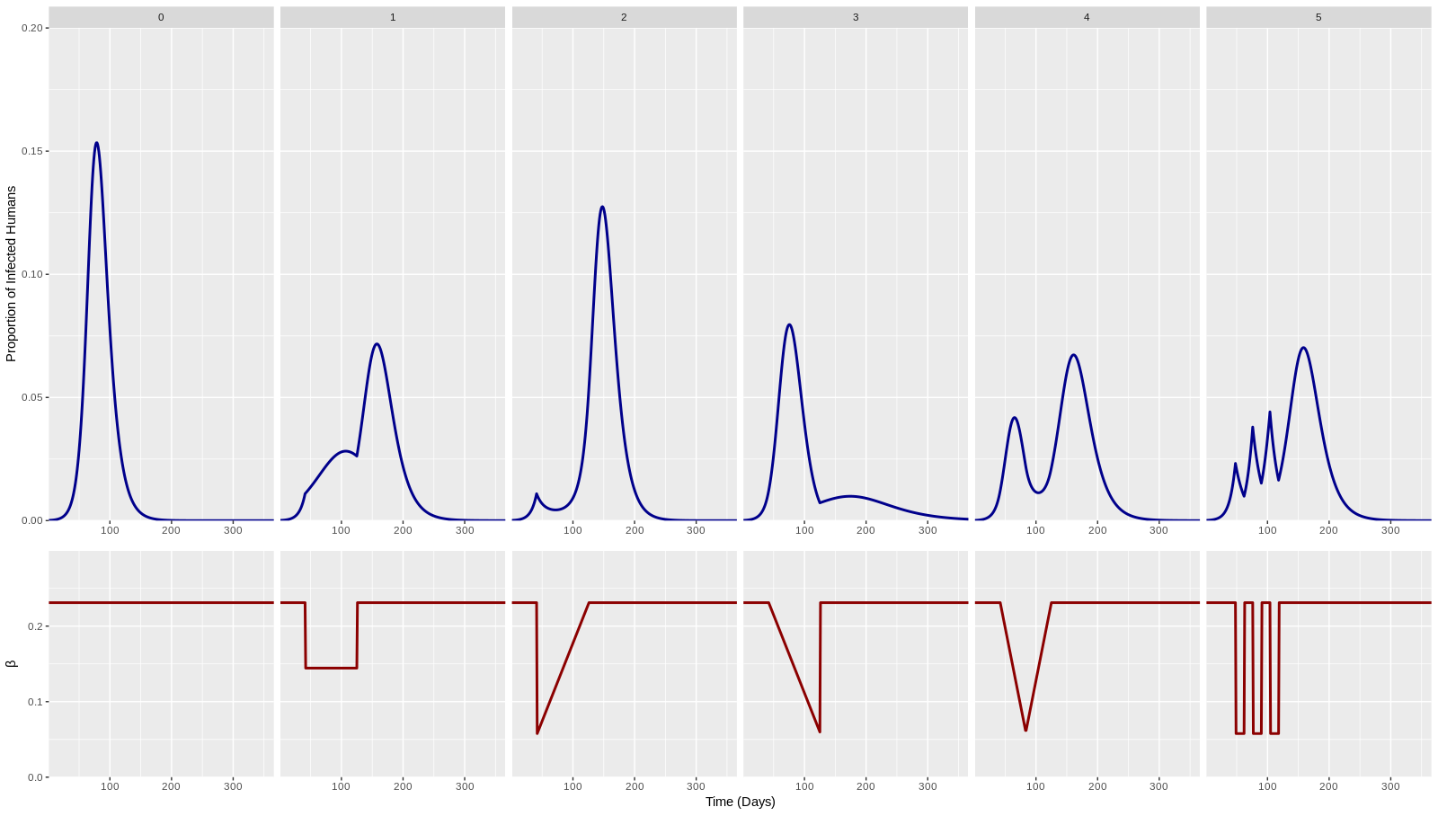

Figure 1. Baseline + 5 scenarios for different β(t) curves.

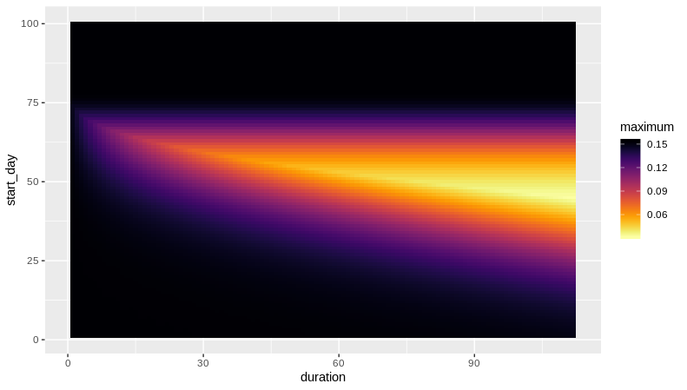

Figure 2. Optimisations with respect to timing and duration (heatmap / 3D plot of paek I(t) over trigger-day & duration space). Optimisation for peak I(t) and final size (A & B)

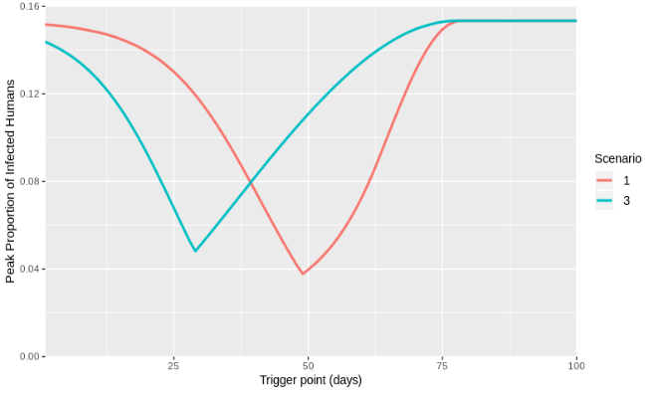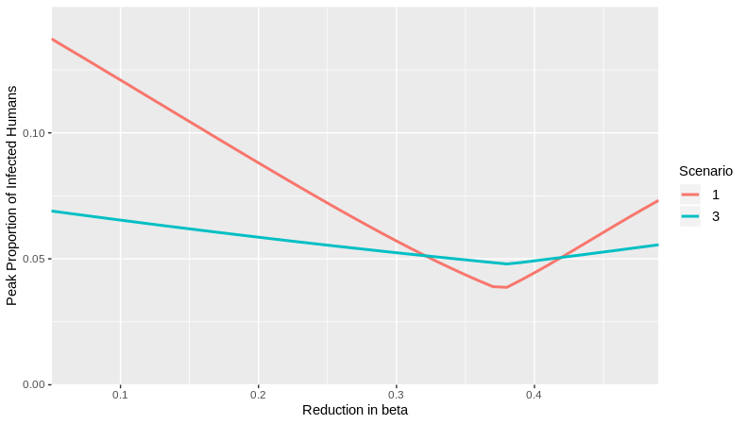

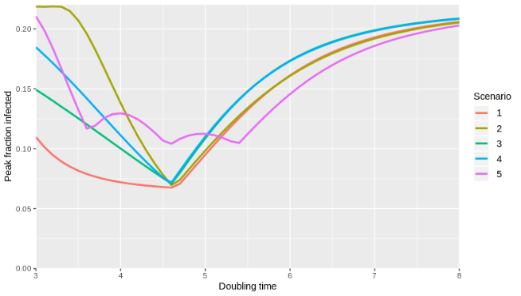

Figure 3. Costs of being wrong: wrong timing / different R­0 / beta / T2. (line plots of tp vs. peak Inf/ final size)

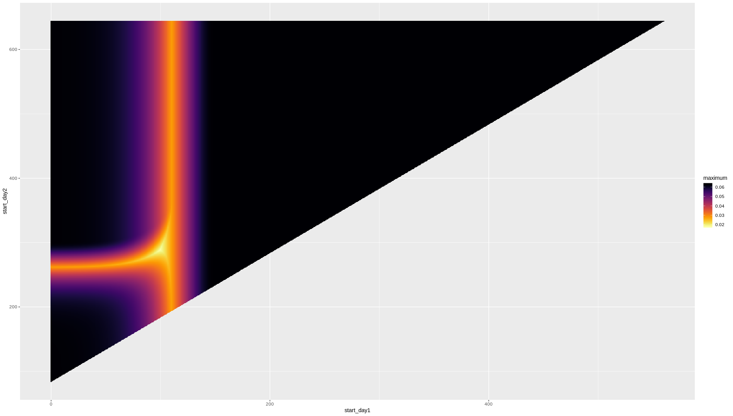

Figure 4. Multiple interventions. Optimising for 2 trigger points and 2 durations. Heatmap for triggerpoints and for durations. Think about combined 4D plot.

## Discussion

What strategy is best / differences between them / on what does being best depend? Where to optimise for?

How bad is it to be wrong? How does this differ for the different strategies?

Caveats of simple model

Conclusions / Recommendations for policies.